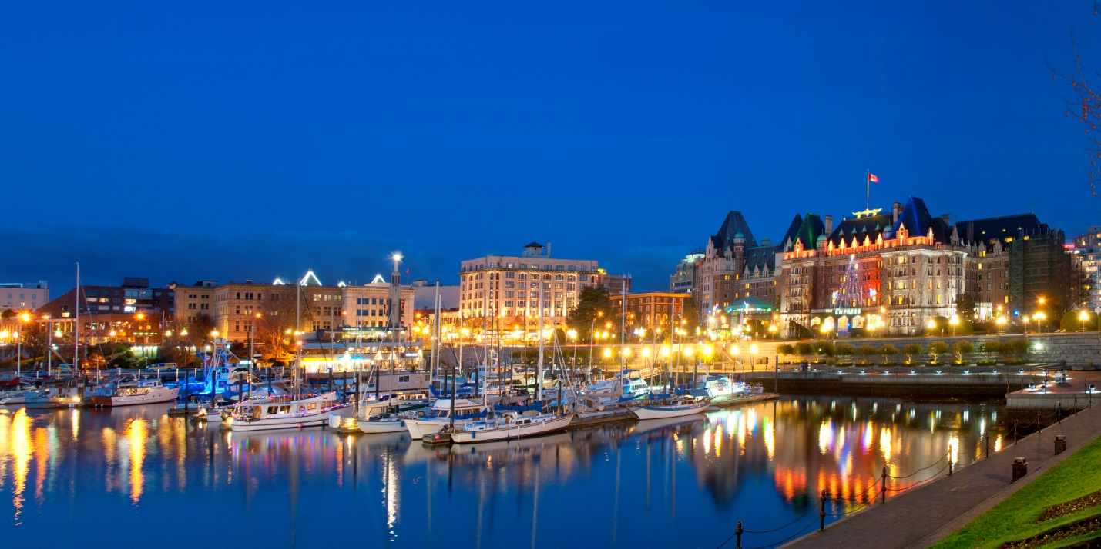
PNWSCT CALL FOR PAPERS

The Pacific Northwest Society of Coatings Technology (PNWSCT) invites presentations for the CoatingsFest to be held from Wed October 10 to Friday October 12, 2018 ^{th} at the Inn at Laurel Point – in the beautiful Victoria, BC.
The technical program will begin on October 11 and will extend for a half-day on October 12. Presentations should focus on the future of paint manufacturing in the Northwest, and new product technology designed for the future. Presentations will be 20-25 minutes long.

Those interested should submit an abstract of 250 words or less, including the paper title and contact information, such as author names, company name, address, phone, fax, email address, and speaker bio. The deadline for the Call for Papers is on June 15, 2018. The Society will send out a notification of acceptance by June 30, 2018.
Abstracts should be submitted to Thelma Longakit at tlongakit@cloverdalepaint.com . Please contact Thelma Longakit at 604-594-6211 for additional information.

